The City  Mouse
and the Country  Mouse

A little mouse lives in the country invites a little Mouse from the city to visit him. The little City Mouse sits down to dinner  he sees that the Country Mouse has only barley 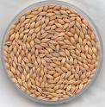 and grain .

He said, you do not live well. Come to see how I live! I have fine things to eat  every day and how nice is the city.
The little Country Mouse is happy and goes to the city to visit his friend.

 | The 1st place they go is the kitchen cupboard 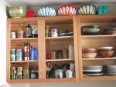 in the house. There is a big paper bag of brown sugar. The little City Mouse invites his friend to eat.
The two little mice eat and eat and the Country Mouse sais how delicious it is and how lucky the City Mouse is. Suddenly the door 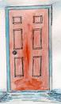 opened and the cook  comes in.

"Run!" whispered the City Mouse. And they run and run to go to the hole 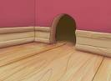 and the little Country Mouse shakes.
The 2nd place they go is the top shelf with a big jar of dried prunes.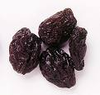 This is better than the brown sugar. The little Country Mouse likes it but suddenly the cat comes MIAOUW!

"What is that?" sais the Country Mouse. The City Mouse sais "Sh!" and runs fast to the hole. | 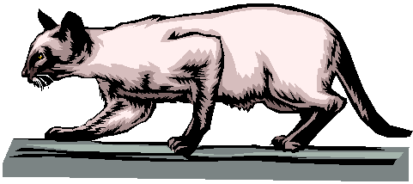
"This is terrible," said the little Country Mouse.

The 3rd place they go is the cellar 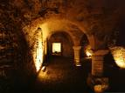.

The City Mouse goes with the little friend to the cellar to a big cupboard with shelves. On the shelves are jars of butter 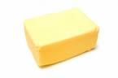, and cheeses 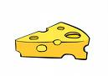and sausages 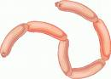. The little Country Mouse sees a cheese and goes to eat it.

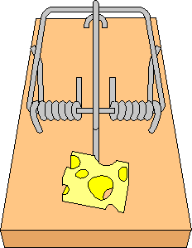 | "Stop! stop!" sais the City Mouse. "That is a trap!"  The little Country Mouse stopps and sais, "What is a trap?"  "This is a trap," sais the little City Mouse. You eat this cheese and something comes down on your head and you are dead."
The little Country Mouse looks at the trap, and he looks at the cheese, and he looks at the little City Mouse. "Excuse me," he sais, "I go home. I rather want barley and grain in peace and comfort, than eat brown sugar, dried prunes and cheese--and be frightened to death all the time!"

And so the little Country Mouse goes home. | 

